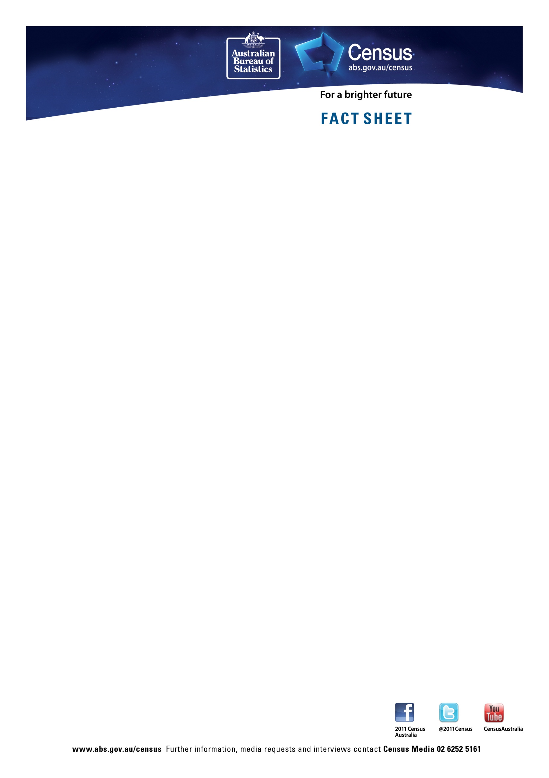

Dwelling structure – Australia and capital cities
Australia | 2011 | 2006
Separate house | 73.8% | 74.3%
Semi-detached (terrace/townhouse) | 9.9% | 9.3%
Flat/Unit/Apartment | 14.6% | 14.7%
Other | 1.5% | 1.6%

Sydney
Dwelling structure | 2011 | 2006
Separate house | 58.9% | 60.9%
Semi-detached (terrace/townhouse) | 12.8% | 12.0%
Flat/Unit/Apartment | 27.6% | 26.4%
Other | 0.6% | 0.7%

Melbourne
Dwelling structure | 2011 | 2006
Separate house | 71.1% | 71.6%
Semi-detached (terrace/townhouse) | 11.8% | 11.4%
Flat/Unit/Apartment | 16.6% | 16.4%
Other | 0.5% | 0.6%

Brisbane
Dwelling structure | 2011 | 2006
Separate house | 77.6% | 78.7%
Semi-detached (terrace/townhouse) | 8.8% | 7.2%
Flat/Unit/Apartment | 12.8% | 13.1%
Other | 0.8% | 1.0%

Adelaide
Dwelling structure | 2011 | 2006
Separate house | 75.8% | 76.2%
Semi-detached (terrace/townhouse) | 12.6% | 12.1%
Flat/Unit/Apartment | 11.2% | 11.2%
Other | 0.3% | 0.4%

Perth
Dwelling structure | 2011 | 2006
Separate house | 76.7% | 77.5%
Semi-detached (terrace/townhouse) | 12.4% | 12.1%
Flat/Unit/Apartment | 10.3% | 9.8%
Other | 0.5% | 0.6%

Darwin
Dwelling structure | 2011 | 2006
Separate house | 60.3% | 62.2%
Semi-detached (terrace/townhouse) | 12.6% | 10.5%
Flat/Unit/Apartment | 21.2% | 20.9%
Other | 5.5% | 6.3%

Hobart
Dwelling structure | 2011 | 2006
Separate house | 81.2% | 81.9%
Semi-detached (terrace/townhouse) | 6.7% | 6.2%
Flat/Unit/Apartment | 11.4% | 11.2%
Other | 0.6% | 0.7%

Canberra
Dwelling structure | 2011 | 2006
Separate house | 70.7% | 73.9%
Semi-detached (terrace/townhouse) | 14.9% | 13.8%
Flat/Unit/Apartment | 14.2% | 12.1%
Other | 0.3% | 0.2%

Dwelling structure – states and territories

NSW
Dwelling structure | 2011 | 2006
Separate house | 67.9% | 69.1%
Semi-detached (terrace/townhouse) | 10.7% | 9.8%
Flat/Unit/Apartment | 20.0% | 19.5%
Other | 1.2% | 1.4%

VIC
Dwelling structure | 2011 | 2006
Separate house | 75.8% | 76.2%
Semi-detached (terrace/townhouse) | 9.6% | 9.2%
Flat/Unit/Apartment | 13.7% | 13.6%
Other | 0.8% | 0.9%

QLD
Dwelling structure | 2011 | 2006
Separate house | 75.7% | 75.4%
Semi-detached (terrace/townhouse) | 8.4% | 7.6%
Flat/Unit/Apartment | 13.3% | 14.2%
Other | 2.5% | 2.7%

SA
Dwelling structure | 2011 | 2006
Separate house | 78.9% | 78.8%
Semi-detached (terrace/townhouse) | 10.8% | 10.6%
Flat/Unit/Apartment | 9.3% | 9.5%
Other | 0.9% | 1.1%

WA
Dwelling structure | 2011 | 2006
Separate house | 78.1% | 78.6%
Semi-detached (terrace/townhouse) | 10.8% | 10.6%
Flat/Unit/Apartment | 8.8% | 8.5%
Other | 2.1% | 2.2%

NT
Dwelling structure | 2011 | 2006
Separate house | 62.0% | 63.7%
Semi-detached (terrace/townhouse) | 10.8% | 9.9%
Flat/Unit/Apartment | 17.3% | 15.8%
Other | 9.2% | 10.4%

TAS
Dwelling structure | 2011 | 2006
Separate house | 85.6% | 86.0%
Semi-detached (terrace/townhouse) | 5.4% | 4.1%
Flat/Unit/Apartment | 7.8% | 8.6%
Other | 1.2% | 1.3%

ACT
Dwelling structure | 2011 | 2006
Separate house | 70.7% | 73.9%
Semi-detached (terrace/townhouse) | 14.9% | 13.8%
Flat/Unit/Apartment | 14.2% | 12.1%
Other | 0.3% | 0.2%

