DataLab Safe Researcher training

Part 3: Safe Outputs and statistical disclosure
control
Overview

Part 1 - Working together

Break (10 minutes)

Part 2 - Maintaining data confidentiality

Break (10 minutes)

Part 3 - Statistical disclosure control
• ABS vision
• Shared accountability
• Five Safes Framework

• What is it?
• Why it’s important
• Your role and the ABS’ role

• How might disclosure occur?
• Making outputs safe
• Output Rules
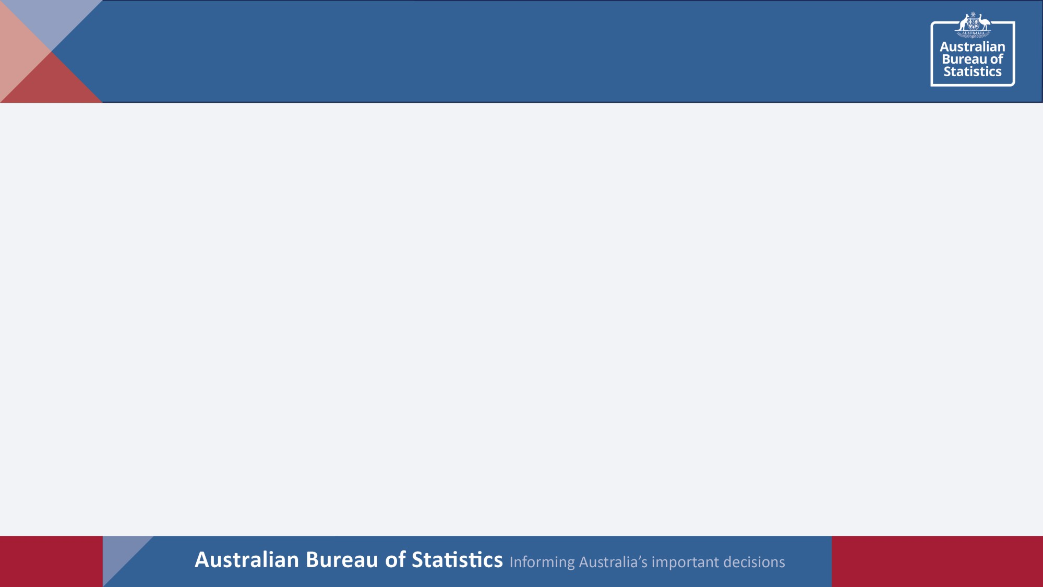

2
Training outcomes
At the end of this training module, you should…

▪ Understand concepts in statistical disclosure
control

▪ Know how to prepare safe outputs that are
non-disclosive
Video: Dr Felix Ritchie

Associate Professor, University of the West of England
Why is output checking important?

• Legal – Only data that is not likely to be identified may
be released
• Departments – Confidence that the data they are
custodian of won’t lead to disclosure

• Providers – People and businesses can have confidence their information is handled appropriately
• Practical – Users don’t need to know everything that
the ABS has released
• But – It’s a shared responsibility
Collaboration in producing non-disclosive outputs

• Principles-based output checking
• Follow the DataLab output rules
• Talk with us when you want to break a DataLab
output rule
– Important
– Uncommon
– Non-precedent setting
• Early warning for fast outputs
Outputs from the DataLab

▪ Everything is checked by staff in the ABS DataLab
Clearance team before it leaves the DataLab
▪ Safe Outputs
▪ How do we check outputs?
▪ How do you know which outputs are OK?
▪ What do you do if we reject your output?

▪ What statistical disclosure control (SDC) can you do to make your outputs acceptable?
Statistical disclosure control

▪ What is SDC?

▪ Checking for disclosure risk in results intended for publication

▪ Mitigating risks by changing the output

▪ Being precautionary
▪ But balancing risk and utility

▪ Consistent with good research

▪ Rule of 10

Each cell should have at least 10 units contributing

Counts of less than 10 should not be able to be worked out

▪ Look at the proposed outputs and we will discuss:

▪ What if anything in these outputs could be a disclosure risk?

▪ What could be done to make it safer (if necessary)?

▪ What would you want to tell the output checkers?

▪ Any other issues or thoughts?

Example 1 – fortnightly income

 | Count | %
Nil income | 8 | 4.5
$1-$500 | 10 | 5.6
$501-$1000 | 40 | 22.5
$1001-$1500 | 40 | 22.5
$1501-$2000 | 45 | 25.3
$2001-$2500 | 25 | 14.0
$2501 or more | 10 | 5.6
Total | 178 | 100.0

Example 2 – Jobmaker counts over time by age brackets

Age
Week | 30-35 | 36-40 | Total
1 | 135 | 124 | 259
2 | 132 | 99 | 231
3 | 99 | 92 | 191
4 | 100 | 138 | 237
5 | 91 | 120 | 211
6 | 127 | 79 | 206

Example 3 – Count of businesses by rating (score customers give businesses from 1-10)

Business rating | Count | % | Cumulative %
1 | 12 | 11.65 | 11.65
2 | 1 | 0.97 | 12.62
3 | 6 | 5.83 | 18.45
4 | 14 | 13.59 | 32.04
5 | 13 | 12.62 | 44.66
6 | 20 | 19.42 | 64.08
7 | 1 | 0.97 | 65.05
8 | 14 | 13.59 | 78.64
9 | 12 | 11.65 | 90.29
10 | 10 | 9.71 | 100.00

Example 4 – Jobmaker counts over time by age brackets

Age

Week | 30-34 | 35-40 | Total
1 | 120 | 139 | 259
2 | 126 | 105 | 231
3 | 85 | 106 | 191
4 | 76 | 162 | 237
5 | 76 | 135 | 211
6 | 117 | 89 | 206

Example 2 Example 4

 | Age  Week 30-35 36-40 Total  1 135 124 259 |  | Age  Week 30-34 35-40 Total  1 120 139 259
 | 2 132 99 231 |  | 2 126 105 231
 | 3 99 92 191  4 100 138 237  5 91 120 211  6 127 79 206 |  | 3 85 106 191  4 76 162 237  5 76 135 211  6 117 89 206

▪ Dominance rules

▪ the largest contributor should not contribute more than
50% to the cell total

▪ the two largest contributors should not contribute more than 67% to the cell total

▪ Look at the proposed outputs and discuss:

▪ What if anything in these outputs could be a disclosure risk?

▪ What could be done to make it safer (if necessary)?

▪ What would you want to tell the output checkers?

▪ Any other issues or thoughts?

Example 5 – Profits of pharmacies in local government areas

LGA | Profits ($M) | Count | Top contributor | Top two contributors
1 | 1.65 | 12 | 40% | 76%
2 | 0.94 | 11 | 15% | 29%
3 | 3.22 | 20 | 55% | 65%
4 | 2.1 | 10 | 35% | 57%
5 | 2.05 | 16 | 42% | 56%
Total | 9.96 | 69 | 18% | 26%

Example 7 – Regression coefficients under 4 different models

Variable  Var1 | Model 1  1.092*** (134.76) | Model 2  0.939*** (62.36) | Model 3  0.992*** (31.53) | Model 4  0.979*** (78.23)
Var 2 | 0.099*** (31.07) | 0.147*** (26.98) | 0.152*** (10.37) | 0.165*** (29.79)
Var 3 |  | -0.058*** (-3.79) | 0.060* (-1.91) | 0.051*** (3.92)
Var 4 |  |  | -0.057 (-1.22) | 0.021* (1.69)
Var 5 |  |  |  | -0.002*** (-7.27)
const | -0.002 (-0.15) | -0.029 (-1.02) | 0.197** (2.03) | 0.102*** (3.69)
N | 74685 | 24432 | 2805 | 23788
r2 | 0.196 | 0.386 | 0.692 | 0.898

β-coefficient (t statistics in parenthesis) * = p<0.1, ** = p<0.05, *** = p<0.01

Example 8 – Characteristics of 2063 households in selected suburb
Weekly household
nels Size o  0 | f household  1 | income  0
0 | 1.5 | 1025
1 | 3 | 2368
0.7 | 2.9 | 2554
0.46 | 2.7 | 823
1 | 5.1 | 3247
1 | 13 | 4987

Min

1st quartile Median Mean
SD

3rd quartile

Max
Has solar pa

▪ Combine categories
▪ Round to the nearest 5, 10, 100, 1000, 10000, …
▪ Perturb / add noise
▪ Use words to describe the table
▪ E.g. “The relative proportions for population X is similar to
population Y”
▪ Suppression (remember secondary)

▪ A note on regressions and modelling

▪ Most of the time regressions are fine. A few things to
be aware of:

▪ Low numbers (ie <10 degrees of freedom)

▪ Removing some records and redoing the regression

▪ High r2 (>0.8 may have disclosure issues)

▪ Categorical variables

▪ Group (class) disclosure

▪ No cells should contain more than 90% of the column or row total

Award wage

Senior

Executive
teacher
Age of teacher | 18-19 year old | Junior teacher
19-20 | 15 | 7
21-25 | 0 | 34
26-30 | 0 | 26
31-35 | 0 | 12
36-40 | 0 | 0

teacher
0 0

3 0

11 0

15 8

27 12
Requesting output clearance

▪ Help us clear your output quickly by:

➢ Adhering to the output rules

➢ Using your clearance folder

➢ Requesting clearance in a new email chain

➢ Providing detailed descriptions in each field of the output
template

▪ We are human, we make mistakes

▪ Inform us if we have made a mistake in clearing your
output

▪ Don’t use files that have been cleared incorrectly

▪ Delete files and email when requested

▪ Mistakes are investigated for potential breaches and if found to be a breach will be treated accordingly.
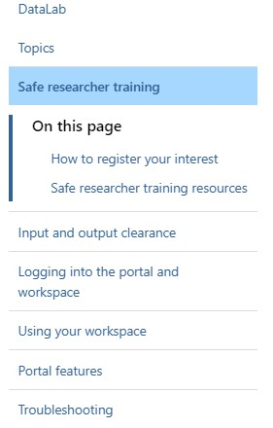Questions and support

DataLab User Guide:
https://www.abs.gov.au/statistics/
microdata-tablebuilder/datalab

DataLab contacts: General enquiries: mailto:data.services@abs.gov.au
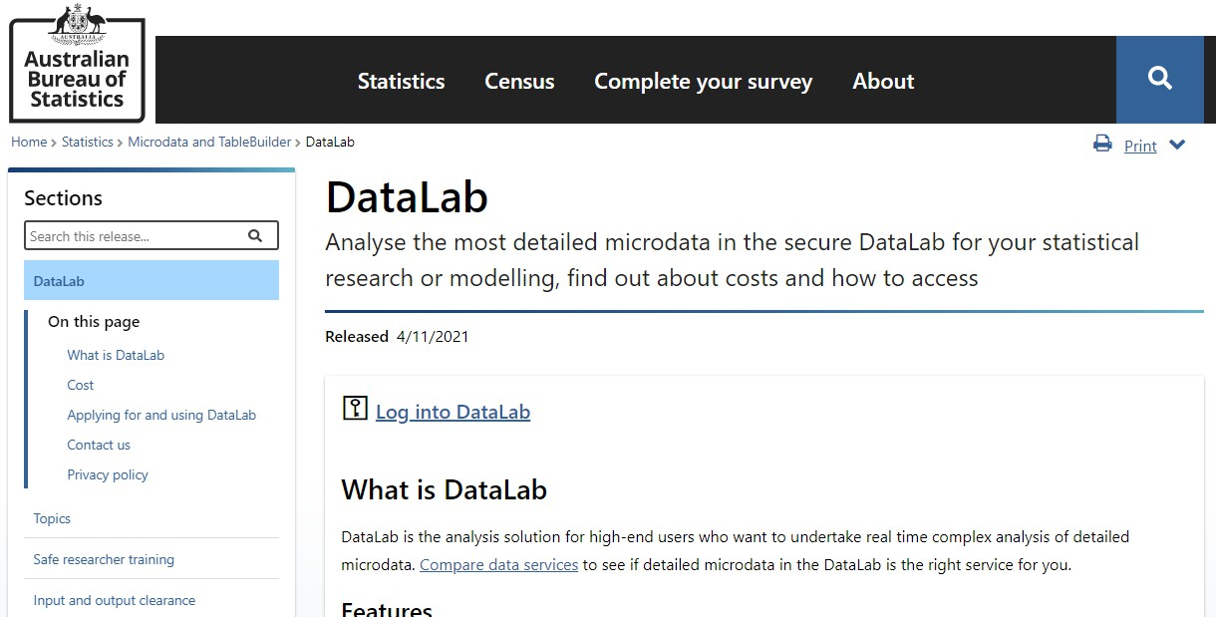Accessing the ABS DataLab from the User Guide

