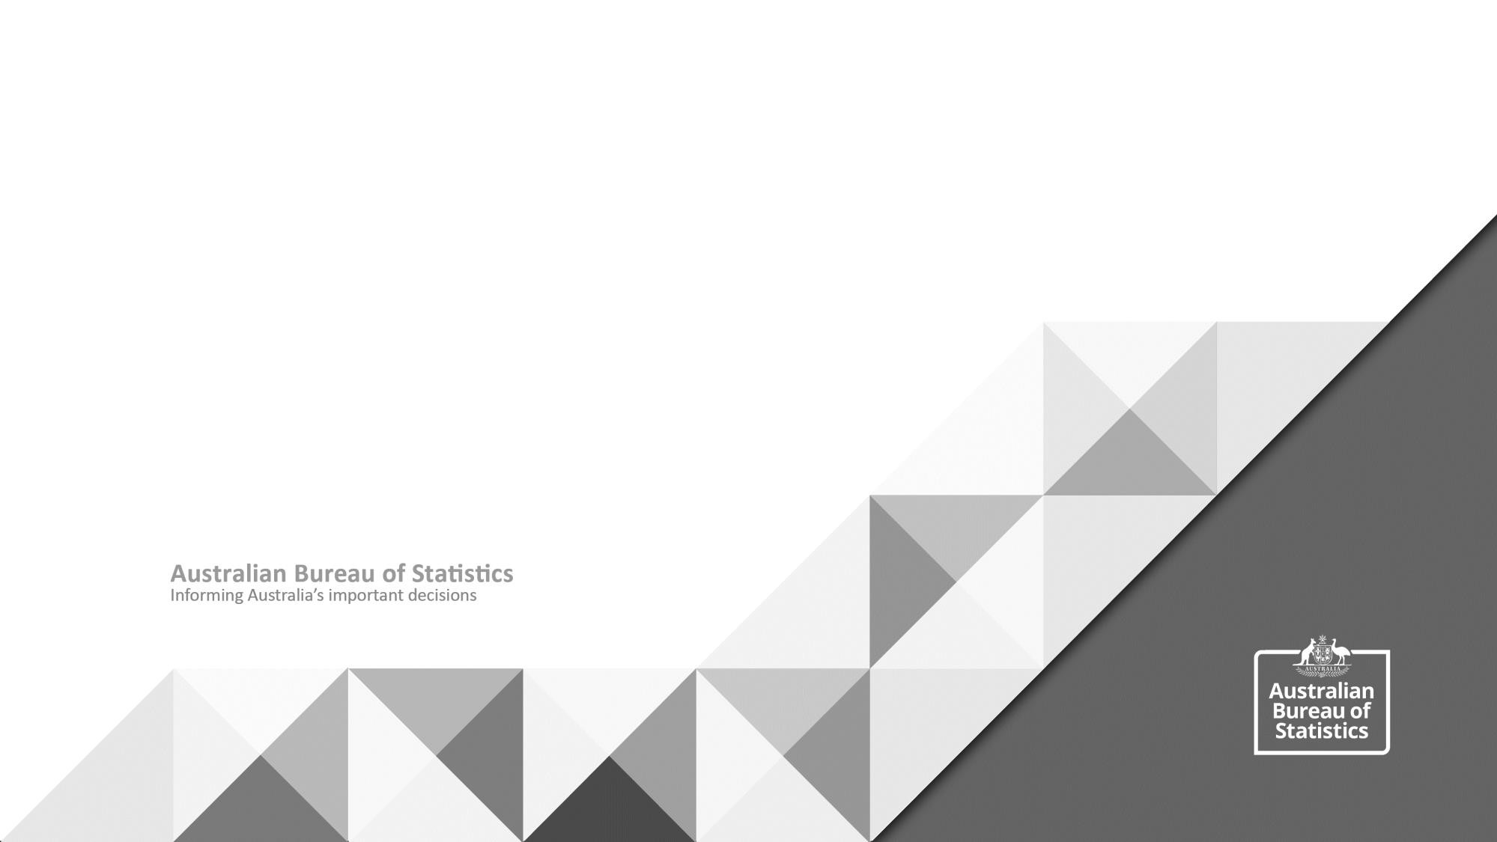
DataLab Safe Researcher Training

General Housekeeping
Overview

Part 1 - Working together

Break (10 minutes)

Part 2 - Maintaining data confidentiality

Break (10 minutes)

Part 3 - Statistical disclosure control

• ABS vision
• Shared accountability
• Five Safes Framework

• What is it?
• Why it’s important
• Your role and the ABS’ role

• How might disclosure occur?
• Making outputs safe
• Rules of thumb
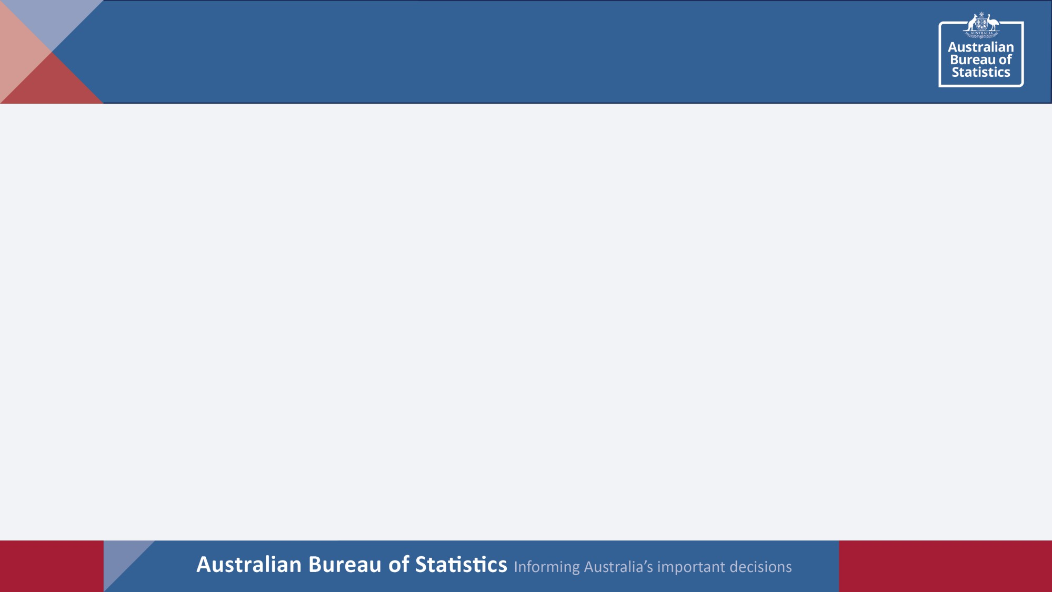
2
Training outcomes - At the end of today you will

▪ Understand your and the ABS’ roles in shared
accountability around the access and use of detailed
microdata in the DataLab

▪ Understand how the five safes framework underpins ABS
disclosure risk assessment

▪ Know how to apply statistical disclosure control

3
Introduction

In 30 seconds (or less) introduce yourself and tell us:

• The data you will be working with, i.e., MADIP, BLADE
or other survey data

• Your role on the project, i.e., analyst or manager/
support person

4
How much do you already know?
Q1: When should the confidentiality of data be protected?
A. Only if the data are sensitive.
B. Unless the data are already in the public domain. C. When data are deemed to be personal.
D. Always.
Q3. Risks from | A. | Minimised.
sharing data should | B. | Controlled using subjective
be? |  | measures.
 | C. | Absolutely zero.
 | D. | Controlled using objective
 |  | measures.

Q2. Which is the most | A. | Mistakes
common reason behind | B. | ignorance
breaches of procedure | C. | Laziness
when sharing data? | D. | Malicious intent
 | E. | Dislike of procedures

the wrong thing.
Q4.Researchers are best | A. | Giving them data to do with as they please.
supported by? | B. | Only letting them have open data.
 | C. | Ensuring they understand their rights and responsibilities.
 | D. | Ensuring they understand that they will be prosecuted if they do

Evaluation of first exercise

Knowledge

Generalist
Specialist

Q1 –Q4

Experience

Today: mostly obvious, lots of thinking

6
Video: Dr Felix Ritchie

Associate Professor, University of the West of England
Consider what could go wrong

Group A | A PhD student downloads DSS and DoH datasets from data.gov.au to  undertake preliminary study into health outcomes
Group B | A researcher has ethical approval to study outpatient outcomes from hospital data and demographics from DHS data. The data are emailed separately and stored on the researchers laptop
Group A | A multi-institutional (university and government) team of researchers access business data in a controlled Federal government facility to investigate sole trader survival
Group B | Government staff in 4 agencies linked identified data from their agencies to create an enduring dataset that will be available for policy development

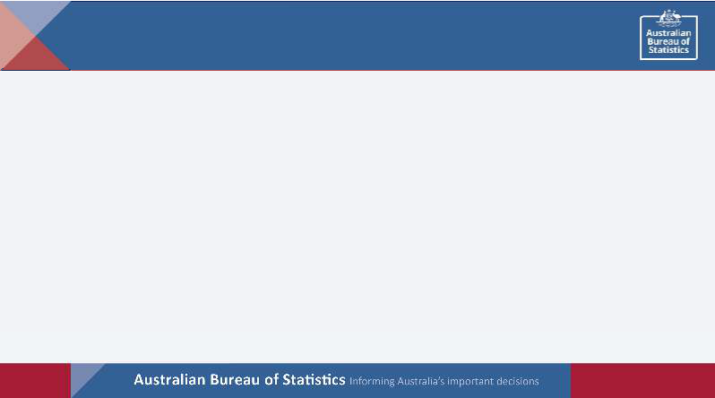
Five safes framework

Safe
People
Is the researcher appropriately
authorised to access and use the data?

Are the statistical results non-disclosive?

Safe
Outputs

Safe
Projects
Is the data to be used
for an appropriate
purpose?

Has appropriate and
sufficient protection been
applied to the data?
Safe
Data
Safe
Settings
Does the access environment prevent unauthorised use?
Exercise: Five safes - Control

Access to detailed microdata in the DataLab
Risk: What is the overall disclosure risk?

Low

High

Med

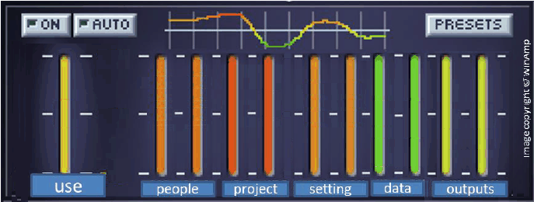
Safe data: Has appropriate and sufficient protection been applied to the data?

Safe outputs: Are the statistical results non-disclosive?
Safe setting: Does the access environment prevent unauthorised use?

Safe project - Is the data to be used for an appropriate purpose?
Safe People - Is the researcher authorised to access and use the data
appropriately?
risk
Low

Adapted based on image from ‘Five Safes: designing data access for research’, Desai, T, Ritchie, F and Welpton, R, 2016
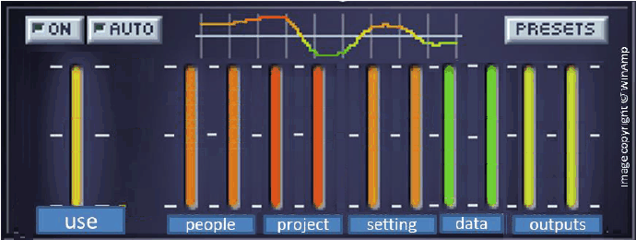Five safes – Other ABS data types

Detailed microdata in the DataLab Microdata download

Risk Risk

ABS TableBuilder ABS website

Risk Risk
Five safes - data

➢ All data in the DataLab should be treated as potentially disclosive

➢ Disclosure risks can be largely managed by non-statistical processes
➢ Detailed data is available for use by researchers in the DataLab, but the final outputs need to be checked for disclosure before being released for use outside the DataLab
Video: Dr Felix Ritchie

Associate Professor, University of the West of England
Recap of part 1

✓ Shared accountability is critical to safe and effective use
of microdata

✓ The ABS has adopted the five safes framework for
managing disclosure risk

✓ Collaboration and feedback will improve ABS microdata
and access processes

Break – 10 mins
Overview

Part 1 - Working together
(50 minutes)

Break (10 minutes)

Part 2 - Maintaining data confidentiality
(40 minutes)

Break (10 minutes)

Part 3 - Statistical disclosure control
(50 minutes)
• ABS vision
• Shared accountability
• Five Safes Framework

• What is it?
• Why it’s important
• Your role and the ABS’ role

• How might disclosure occur?
• Making outputs safe
• Rules of thumb
16
Discussion

▪ Question: Is confidentiality our highest priority for microdata in
the DataLab?

▪ Answer: No
➢ Our highest priority is providing researchers access to useful microdata
➢ Confidentiality is now a constraint

▪ But: We need a high priority on confidentiality when data is
made public (covered in Part 3)
Data confidentiality

▪ All users accessing microdata are legally required to protect data confidentiality

▪ Legal and non-legal sanctions apply to any breaches and not complying with terms and conditions has consequences
Understanding legal issues and impacts

▪ Looking at the following scenarios:

▪ Is there a breach of confidentiality?

▪ Is there a breach of procedure?

▪ Are there any other issues (e.g. ethical)?
Exercise - Scenario 1

A researcher is accessing a Detailed Microdata file in the DataLab
environment. They take some notes on paper from the screen about
records with particular characteristics (e.g. crime records). They do
not show the ABS the paper notes for vetting, and subsequently
misplace the piece of paper.

Group A: identify the legal, ethical or procedural issues here?
Group B: Convince us this scenario is fine.
Exercise - Scenario 2

A government officer is conducting research in the DataLab. Their supervisor is also named on the project, although the supervisor is not actively involved in the research. They discover some really interesting results and are excited to share it with their supervisor. They send an email to their supervisor with a copy of the analysis.

Group B: identify the legal, ethical
or procedural issues here?
Group A: Convince us this scenario
is fine.
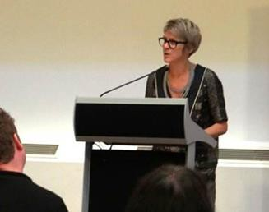Exercise - Scenario 3

A researcher presents a seminar at a conference using analysis from
business unit record data. In addition to their vetted analysis, they
describe data about a business with particular characteristics,
located in a particular region. Someone in the audience believes
that the business being described is a manufacturing firm in SA.

Group A: identify the legal, ethical or procedural issues here?
Group B: Convince us this scenario is fine.
Your role

▪ Key things to remember:
▪ Do not disclose any microdata
▪ Do not attempt to circumvent the system
▪ Do follow the rules and processes of the DataLab system
▪ For your ongoing reference, there is a longer list of DO’s and
DON’T’s online in the ABS DataLab User Guide and the pre-reading

▪ And, if you are ever unsure, always reach out and ask us by emailing: mailto:data.services@abs.gov.au
ABS role

▪ Check outputs and provide you with advice on how to make your
outputs non-disclosive

▪ Respond to any questions related to the data, processes and systems
▪ Respect your academic independence
▪ For more information, refer to the ABS DataLab User Guide
Security protocols

▪ Do not capture on-screen information in any way during your DataLab session
▪ When accessing DataLab you must:

• access the microdata in a work or private location

• protect the screen from oversight by other people, and

• use a secure internet connection
▪ Do not share login details with anyone
▪ This is critical for maintaining confidentiality and managing public perception
regarding data care

▪ For more detail, please read: https://www.abs.gov.au/statistics/microdata- tablebuilder/responsible-use-abs-microdata/microdata-user-obligations
Recap of part 2

✓ ABS staff, inposted officers and researchers are legally and ethically required to maintain data confidentiality

✓ Breaches of confidentiality and not complying with an undertaking potentially have legal and/or non-legal consequences

✓ Legislation protects confidentiality and privacy whilst enabling access to detailed information in special circumstances

✓ You and the ABS play a role in maintaining data confidentiality

Break – 10 mins

