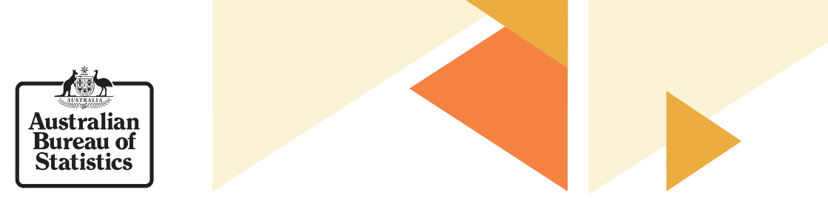

Australian Marriage Law Postal Survey

Australians living in rural and remote areas
The Australian Marriage Law Postal Survey has now closed. Thank you to everyone who participated.

How to find your nearest Post Office or Red Post Box
To help you locate your nearest Post Office or Red Post Box, you could enter your suburb, city or postcode into Australia Post's Locator.

Online or telephone response
In limited circumstances, you could use a Secure Access Code from the ABS to complete the survey online, call the automated telephone service or contact the ABS Customer Assistance Team to provide an anonymous survey response.

Department of Human Services Service Points
If you were in a remote location, you could contact the ABS at more than 600 Department of Human Services (DHS) agents, access points and remote service centres across Australia. In these locations, you could participate in the survey by:
- Using telephones to call the survey Information Line, and/or
- Using self-service computers with the internet to access the ABS website.
Details of DHS service points are available at findus.humanservices.gov.au

Nominate a trusted person to respond on your behalf
As with other ABS collections, people living in remote communities could seek the support of a trusted person to assist with the completion of their survey.

How your materials were delivered?
Materials were posted to any nominated address within Australia, including remote Aboriginal and Torres Strait Islander communities, PO boxes, and nominated identified mailing addresses (shelters, hotels, workers camps, etc.).
If you are living in a remote area:
- Forms were mailed to you by priority post, with priority return Reply Paid mail envelopes.
- Areas with less frequent mail service were posted first, using priority postage.
- Where household delivery was not possible, your mail would have been held at the closest mail agent for you to collect.
- You could pick-up your form at a number of regional and remote locations during the survey period.
- For locations with phone or internet connectivity, people could request a Secure Access Code up until 6pm (local time) 20 October 2017 to respond to the survey online or by phone.
- You can no longer request a replacement survey form or Secure Access Code. Requests for replacement materials closed on 20 October 2017.
- A map showing the drop-off locations was published on this website and was shared with local communities.
- Remote pick-up locations were staffed with ABS Officers with experience in supporting the collection of information in remote communities.

