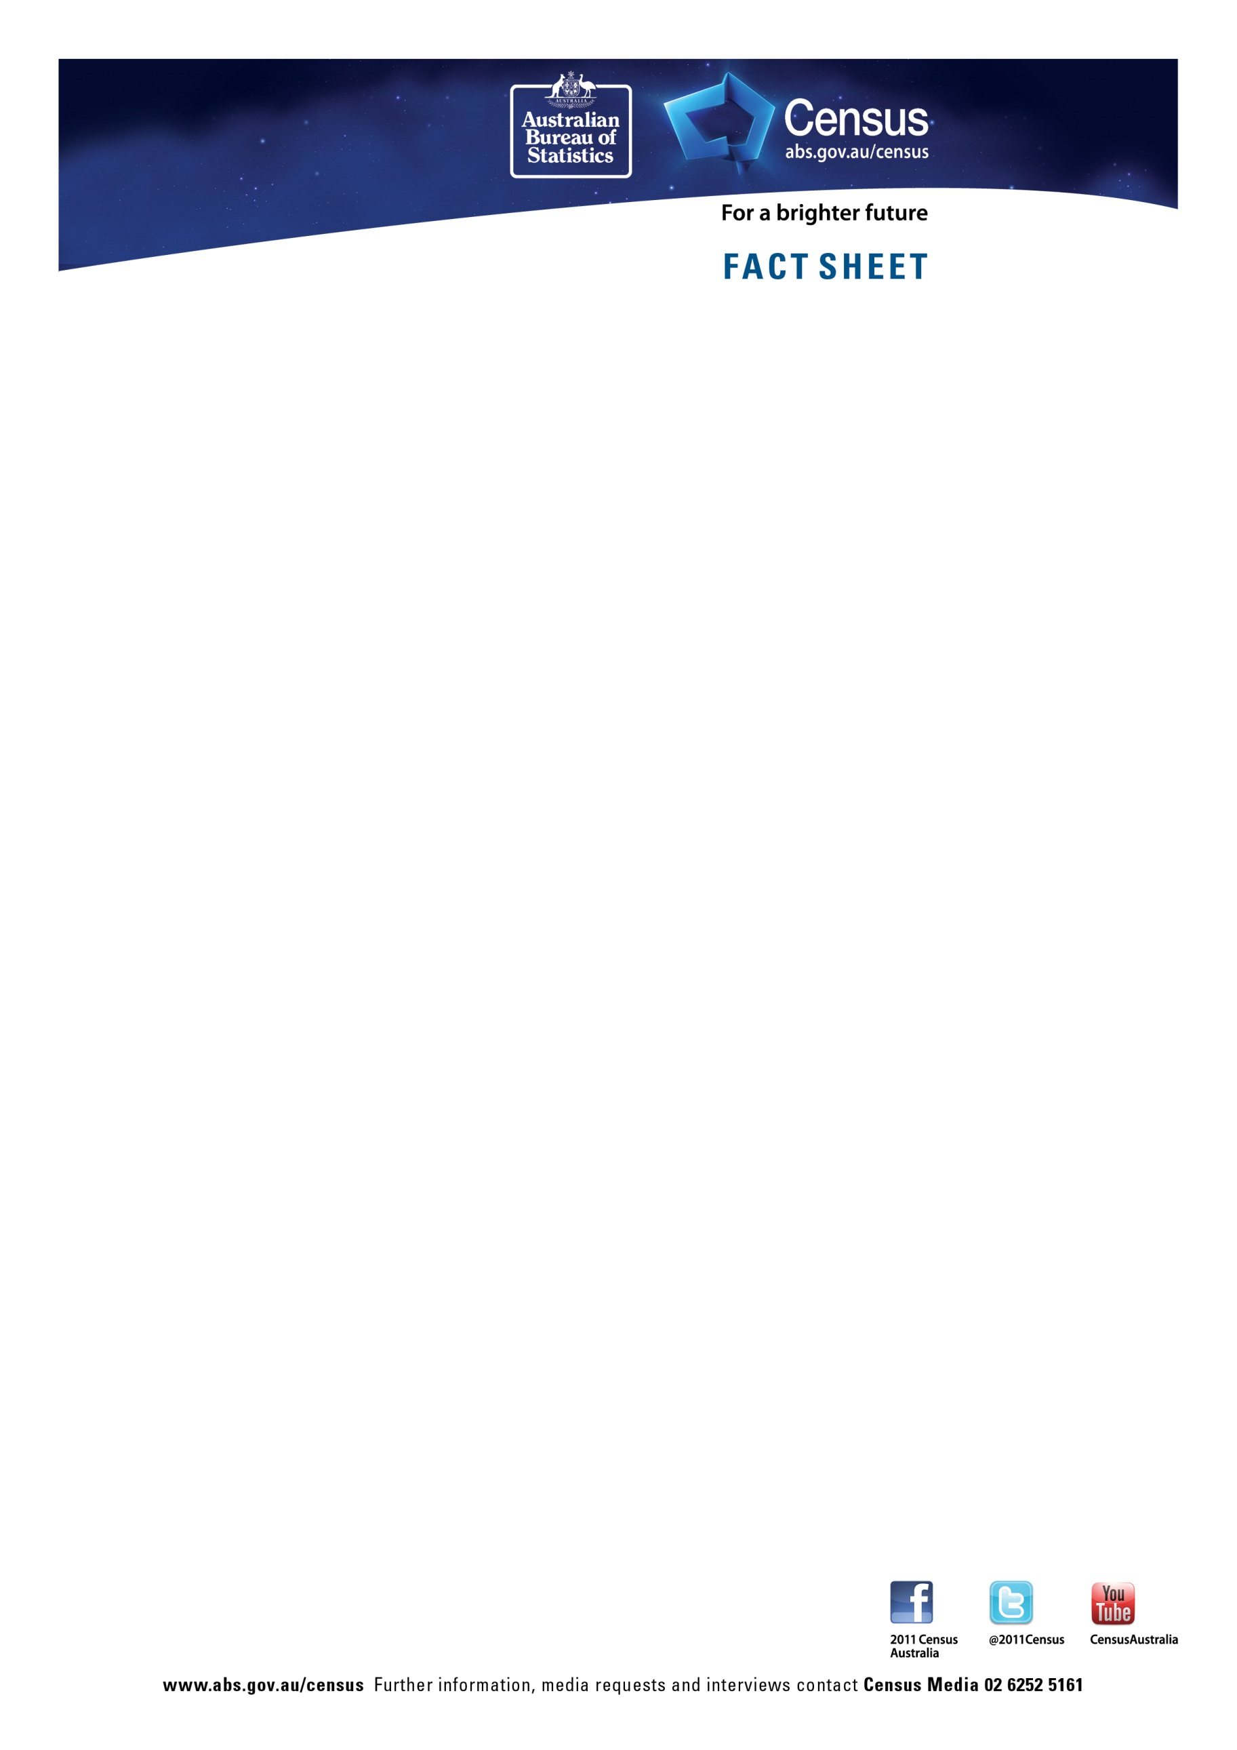

Aboriginal and Torres Strait Islander population – Tasmania

 | 2011 | 2006 | Change
Total Indigenous population | 19,625 | 16,767 | 17.0%
Aboriginal only | 17,742 | 14,878 | 19.2%
Torres Strait Islander only | 1,171 | 1,258 | -6.9%
Both Aboriginal and Torres Strait Islander (a) | 713 | 631 | 13.0%
Median age | 22 | 20 | +2 years
Percentage of males 34 years and under | 67.9% | 69.8% | -1.9%
Percentage of females 34 years and under | 65.6% | 67.6% | -2.f%
Median income – personal (weekly) | 395 | 323 | 22.3%
Median income – household (weekly) | 923 | 774 | 19.3%
Dwellings owned outright | 1,678 | 1,437 | 16.8%
Dwellings owned with a mortgage | 3,175 | 2,739 | 15.9%
Dwellings rented | 4,273 | 3,494 | 22.3%
Median weekly household rent | 190 | 125 | 52.0%
Median monthly household mortgage repayments | 1,300 | 839 | 54.9%
Average people per household | 3.0 | 3.0 | -
Number of people per bedroom | 1.2 | 1.2 | -
Persons who have completed year 12 or equivalent | 2,773 | 2,064 | 34.4%
Attending university or other tertiary institution | 353 | 259 | 36.3%
Full time students | 5,801 | 5,159 | 12.4%
Part time students | 1,063 | 876 | 21.3%
- Persons who are of both Aboriginal and Torres Strait Islander origin
Note: Data about dwellings refers to occupied private dwellings containing at least one person of Aboriginal and Torres Strait Islander origin.

