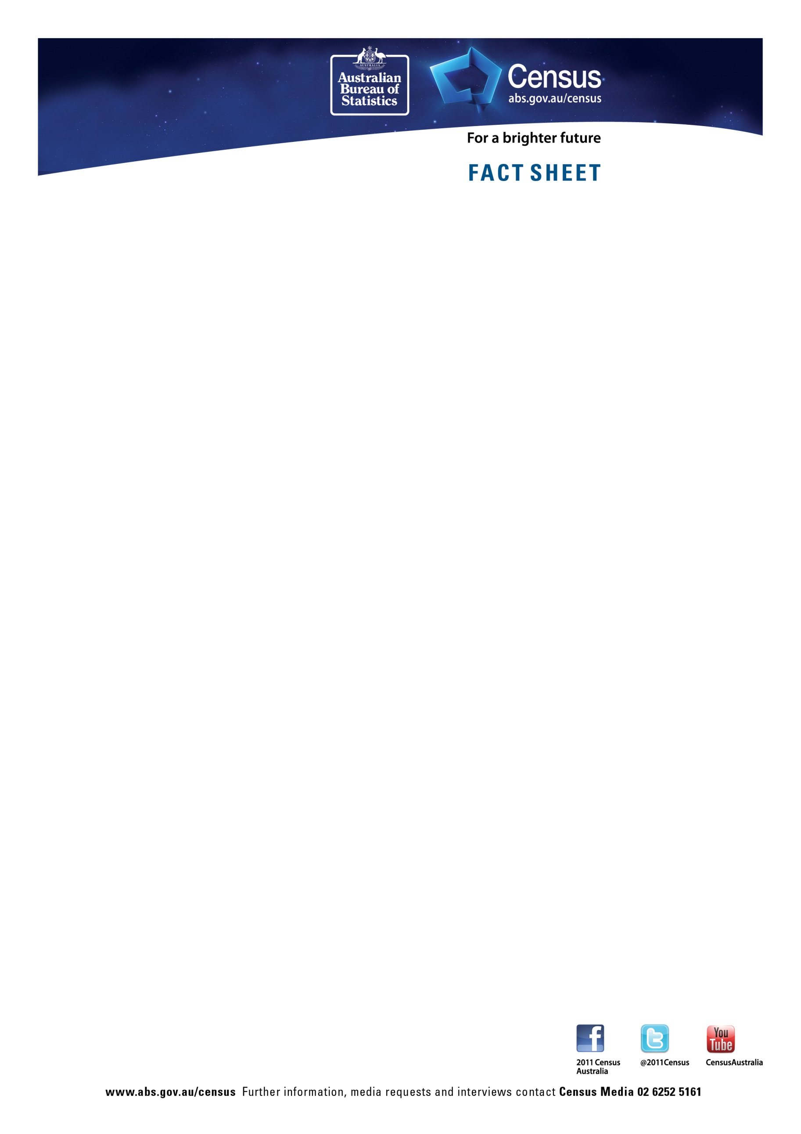

Aboriginal and Torres Strait Islander population – Northern Territory

 | 2011 | 2006 | Change
Total Indigenous population | 56,779 | 53,662 | 5.8%
Aboriginal only | 54,572 | 51,703 | 5.5%
Torres Strait Islander only | 673 | 614 | 9.6%
Both Aboriginal and Torres Strait Islander (a) | 1,533 | 1,345 | 14.0%
Median age | 23 | 22 | +1 year
Percentage of males 34 years and under | 70.4% | 72.3% | -1.9%
Percentage of people 34 years and under – female | 66.5% | 68.8% | -2.3%
Median income – personal (weekly) | 269 | 215 | 25.1%
Median income – household | 1099 | 837 | 31.3%
Dwellings owned outright | 572 | 502 | 13.9%
Dwellings owned with a mortgage | 1,820 | 1,546 | 17.7%
Dwellings rented | 8,531 | 8,059 | 5.9%
Median weekly household rent | 75 | 60 | 25.0%
Median monthly household mortgage repayments | 1,957 | 1,300 | 50.5%
Average people per household | 4.2 | 4.2 | -
Number of people per bedroom | 1.7 | 1.8 | -.1 person
Persons who have completed year 12 or equivalent | 5,026 | 2,967 | 69.4%
Attending university or other tertiary institution | 480 | 470 | 2.1%
Full time students | 14,375 | 11,691 | 23.0%
Part time students | 2,089 | 1,725 | 21.1%
- Persons who are of both Aboriginal and Torres Strait Islander origin
Note: Data about dwellings refers to occupied private dwellings containing at least one person of Aboriginal and Torres Strait Islander origin.

