Australian Bureau
of Statistics

P3M3™ Assessment Report

June 2011

Document History

Date | Version | Author(s) | Description
21/06/2011 | 0.1 | Stefan Gajewski  Sharyn Csanki | Initial draft
28/06/2011 | 1.0 | Stefan Gajewski  Sharyn Csanki | Comments from internal Oakton review have been included

Reviews
This document will be provided to the following groups/individuals for review:
Date | Version | Name | Title
27/06/2011 | 0.1 | Peter Hallams | Service Line Manager

Approvals

Date | Name | Title
 | Mark Bingley | Director, Technology Services

Distribution
Name | Title
Mark Bingley | Director, Technology Services

Disclaimer

Oakton Services Pty Ltd (ABN 31 100 103 268) has used reasonable endeavours to ensure that the contents of this document are correct at the time of publication. However, its officers, employees, agents and advisers:

- Are not, and will not be responsible, or liable for the accuracy or completeness of the contents of this document;
- Make no express or implied warranty that any estimate or forecast will be achieved or that any statement as to future matters will prove correct;
- Expressly disclaim any and all liability arising from this document (including liability arising as a result of negligence) for loss or damage suffered by any person resulting from reliance on this or any other document provided by or on behalf of Oakton, or any indirect or consequential expenses, losses, damages or costs (including, without limitation, liability for loss of profits or revenue, business interruption, loss of data, or failure to realize anticipated savings or benefits); and
- Except as so far as liability under any statute cannot be excluded, accept no responsibility arising in any way from errors in, or omissions from this document, or in negligence.

This document does not constitute advice and Oakton recommends that users exercise their own care, skill and diligence with respect to their use, interpretation and reliance on this document.
Table of Contents

Table of Contents iii
1 Executive Summary 1
1.1 Background 1
1.2 P3M3™ Assessment 1
1.3 Interview Results Summary 1
1.4 Target capability delivery maturity levels 2
1.5 The Capability Improvement Plan 2
1.6 Independent Assessment 2
2 The Assessment Process 3
2.1 The Objective 3
2.2 The Plan 3
3 The Assessment Results 4
3.1 Portfolio Management: Level 2 4
3.2 Programme Management: Level 2 7
3.3 Project Management: Level 2 10
3.4 P3M3™ Sub-Model Process Perspective Scores 12
3.5 P3M3™ Generic Attributes Scores 13
4 Agency Target Maturity Levels 15
4.1 Maturity Targets 15
4.2 Gap Analysis 15
Attachments 16
Attachment A P3M3™ Model and Definitions 17
Attachment B Terminology 20

Executive Summary

Background
The Australian Bureau of Statistics (ABS) is Australia’s official statistical organisation, and is committed to a better informed Australia. As an organisation, the ABS strives to remain relevant to national needs by collecting the right sort of data, processing it to world-leading standards and delivering information solutions to their many clients. ABS mission is to assist and encourage informed decision-making, research and discussion within governments and the community, by leading a high-quality, objective and responsive national statistical service.

P3M3™ Assessment
The following P3M3™ ratings have been derived from the assessment by way of process review and interviewing a selection of twenty three (23) ABS staff to assess the Agency’s maturity of portfolio, programme and project management practices.
The P3M3™ Assessment of ABS’s change portfolio (including ICT-enabled and non ICT) and constituent programmes and projects was conducted by Oakton in two phases in May 2010 and June 2011. There was an increased maturity evident across Portfolio, Programme and Project Management between May 2010 and June 2011, which reflected ABS’s positive response to feedback after the first assessment phase. The result reported was calculated using the assessment results of both phases.
This assessment was conducted in accordance with the Deed of Standing Offer with the Department of Finance and Deregulation for the provision of P3M3 maturity assessment consultancy services. The assessment was also conducted in a manner consistent with APMG guidance.

Interview Results Summary
Oakton’s analysis produced the following maturity level results:

Portfolio Level 2 – Repeatable Process
Management Control Level 3
Benefits Management Level 2
Financial Management Level 3
Stakeholder Management Level 3
Risk Management Level 3
Organisational Governance Level 4
Resource Management Level 3

Programme: Level 2 – Repeatable Process
Management Control Level 2
Benefits Management Level 2
Financial Management Level 3
Stakeholder Management Level 2
Risk Management Level 3
Organisational Governance Level 2
Resource Management Level 2

Project: Level 2 – Repeatable Process
Management Control Level 3
Benefits Management Level 2
Financial Management Level 3
Stakeholder Management Level 2
Risk Management Level 3
Organisational Governance Level 3
Resource Management Level 2
It should be noted that the overall assessed maturity level of Portfolio, Programme and Project Management is equal to the lowest score for the process perspectives.
The definition of maturity level 2 is set out below.

Maturity Level 2 – Repeatable Process
- The Agency ensures that each programme and/or project in its portfolio is run with its own processes and procedures to a minimum specified standard.
- Application of a consistent method across change initiatives is not yet observed.

Target capability delivery maturity levels
Oakton recommends that ABS set target capability delivery maturity levels as follows:
Portfolio = Level 3: Defined Processes
Programme = Level 3: Defined Processes
Project = Level 3: Defined Processes
Capability delivery improvements across ABS Portfolio, Programme and Project Management processes can lead to a more centralised and defined framework with mature investment management processes, fully documented and understood practices combined with defined stakeholder engagement practices, clear roles and responsibilities and central tracking of the realisation of benefits.

The Capability Improvement Plan
The purpose of the Capability Improvement Plan is to express how ABS intends to improve its delivery capability to commission, manage and realise benefits from its investment in business change initiatives. Oakton is recommending a staged approach to capability improvement. The Agency’s Capability Improvement Plan is detailed in a separate paper to this report.

Independent Assessment
This Independent Assessment was conducted by Peter Hallam APMG Registered Consultant - PPMRCAU/026, Stefan Gajewski, APMG Registered Consultant - PPMRCAU/004 and Sharyn Csanki, Principle Consultant.

The Assessment Process

The Objective
ABS’s adopted the following objectives for their P3M3™ assessment:

- Compliance
- Improving Capability Delivery

The Plan
Oakton conducted this review using the APMG P3M3™ Assessment Tool. The following plan outlines the stages, key activities and deliverables of the assignment.

Stage | Key Activities and Deliverable
Assessment Planning | Key Activities  Confirm proposal scope, objectives and deliverables and confirm Interviewees and propose interview schedule  Deliverable  - Assessment Plan
Process Assessment | Key Activities  Review related artefacts  Deliverable  - Draft Report
Application Assessment | Key Activities  Interview twenty three Agency staff * who are currently managing or working in Agency portfolio, programme and project management roles  Deliverable  - Scribed interview results and Draft Report
Assessment Report | Key Activities  Report– document achievements to baseline capability delivery  Workshop – target maturity levels for each sub-model  Deliverable  - Assessment Report
Capability Improvement Plan | Key Activities  Plan –capability delivery priorities  (1 draft and 1 final artefact)  Deliverable  - Capability Improvement Plan
* Interviews were conducted on the basis that the individual interviewee(s) would not be identified.

The Assessment Results
Following is the assessment results with a description of the rationale behind the assessment.
  - Portfolio Management: Level 2
Overall Portfolio Management maturity is assessed as Level 2.
Portfolio Management is at level 2 and not level 1 because:
- Across process perspectives there is a recognised and repeatable set of processes.
- Some processes display a considerable level of maturity, in particular there is a strong alignment of change initiatives to strategic objectives and priorities, risk, stakeholder and financial management show signs of maturity. Internal management controls display the right approach to coordination of portfolio level activities across the organisation.
Portfolio Management is at level 2 and not level 3 because:
- Benefits realisation activities are managed to level 2. There is no benefits management including tracking being consistently applied at the portfolio level.
As the interviews have been conducted in two series, in May 2010 and in June 2011, an improvement in portfolio management maturity has to be noted over this period.
    - Management Control Level 3
Management Control within Portfolio Management was found to be at level 3 and not level 2 because the assessment revealed that the portfolio management processes are centrally defined and understood, as are the roles and responsibility for delivery. The roles of the executive committees including the Capital Strategy Committee are well understood as is the process for approval of new initiatives and ongoing monitoring of programs and projects. The Office of the Statistician and the Project Office of the Technology Services support the portfolio management process with reporting and independent assurance. There is a clear link between the value assessment contained in the business cases for each new initiative which drives the annual plan and associated priorities that are used by the executives to develop a portfolio of initiatives, projects and programs. All new initiatives are centrally considered and approved before becoming a part of the change portfolio.
Management Control within Portfolio Management was found to be at level 3 and not level 4 because the assessment found little evidence of metrics used to measure the performance and success of the portfolio.
    - Benefits Management Level 2
Benefits Management within Portfolio Management was found to be at level 2 and not at level 1 because interviewees regarded this as a repeatable process, that was inconsistent and an area for improvement. Benefits are identified at programme and project level and are contained in the business case documents. There was little evidence on ongoing benefits management although benefits harvesting does occur for changes that had identified savings as their benefits. However, this happens irrespective of the actual verification of the delivery of those savings. While there is a clear link between strategy and the composition of the portfolio, the portfolio benefits realisation step appears to be weak and there is little evidence of central coordination of benefits management at the portfolio level.
Benefits Management within Portfolio Management was found to be level 2 and not level 3 because there is little evidence of a defined benefits realisation and management process being exercised by the executive committees. The definition of benefits happens consistently in the business case documents, however, the quality of those definitions needs improvements with focus on the measurable aspect of those definitions and assignment of accountability for realisation.
    - Financial Management Level 3
Financial Management at the Portfolio level was found to be at level 3 and not level 2 because there are established standards for the investment management process and the preparation of business cases. In addition, portfolio investment costs are monitored by the portfolio executive committees. Longer term (4 yr) and shorter term (annual) financial planning exists. Regular reviews of the portfolio occur and corrective actions are put in place to rectify under or over spend situations.
Financial Management within Portfolio Management was found to be level 3 and not level 4 because there is little evidence of a proactive evidence based management of the costs ABS does not exercise the prediction of future financial performance based on the metrics gathered for programmes and projects, e.g. “estimates to complete” at the programme and project level are not assessed.
    - Stakeholder Management Level 3
Stakeholder Management at the Portfolio level was found to be at level 3 and not level 2 because a standard approach to identifying, managing and communicating with stakeholders exists. External stakeholders are engaged via government or industry bodies at the domestic and international level. Stakeholder Management is strongly exercised at the portfolio level with on-going coordination and specific responsibility allocation to individual executives. A good example of the international stakeholder engagement is the Information Management Transformation Programme that constitutes a portion of the overall effort in this field coordinated among a number of national statistic institutions around the world.
Stakeholder Management within Portfolio Management was found to be level 3 and not level 4 because there is no evidence of plans for managing key portfolio stakeholders and no quantitative data used for analysis, engaging and assessment of stakeholders. However, the ABS conducts assessments of stakeholders’ engagement effectiveness that is an element of level 4 maturity.
    - Risk Management Level 3
Risk Management at the Portfolio level was found to be at level 3 and not level 2 because there is review of the Agency’s risks at the Portfolio level. Portfolio Risk Management is based on the corporate Risk Management Framework. Executives review risks that reflect strategic opportunities and threats as well as the aggregated risks presented by specific change initiatives.
Risk Management within Portfolio Management was found to be level 3 and not level 4 because the techniques for risk assessment and evaluation do not include risk modelling and simulations. There was no evidence demonstrating that risks assessments plays a consistent role for establishing and maintaining the desired balance between threats and opportunities at the portfolio level.
    - Organisational Governance Level 4
Organisational Governance at the Portfolio level was found to be at level 4 and not level 3 because there is a clear alignment of initiatives, programme and project with the strategic objectives. The portfolio is continually reviewed to ensure continued relevance of the portfolio. Projects have been stopped as a result of the review at the Portfolio level. All interviewees have a clear understanding of the portfolio governance and the process for approval of an initiative i.e. CSC for capital projects and ELG/SMG for non-capital projects.
Organisational Governance within Portfolio Management was found to be level 4 and not level 5 because there is no evidence of priority order within the portfolio of programmes and/or projects based on strategic objectives and interdependencies. There is no evidence of continuous improvements to the Organisational Governance processes.
    - Resource Management Level 3
Resource Management at the Portfolio level was found to be at level 3 and not level 2 because the resource management process is well defined with initiative resource needs being evaluated against priorities, corporate strategies and balanced against competing resource needs at the programme and project level. The resource needs of individual programmes and projects are derived based on the WBS technique. There is a standard resource planning process (the annual Forward Work Program) used to determine medium and long term resource needs and capability. The future capability requirements are reflected in the organisational Capability Plan. However, ABS has not fully established capacity strategies and processes for obtaining, allocating and adjusting resource levels (including tools, people and other assets).
Resource Management within Portfolio Management was found to be level 3 and not level 4 because there is no consistent monitoring of ABS utilisation of resources, people specifically, across the portfolio in order to plan, manage and meet resource needs for all new initiatives.
  - Programme Management: Level 2
Overall Programme Management maturity is assessed as Level 2.
Programme Management is at level 2 and not level 1 because:
- Key individuals were found to have practical delivery experience in programme management. The interviews indicated improvement in the understanding of programmes, their specific management practices and their value to the organisation between May 2010 and June 2011
- Across most process perspectives there is a recognised and repeatable set of processes that are consistent with the broad requirements described in the ABS Programme Framework.
Programme Management is at level 2 and not level 3 because:
- Benefits realisation activities are limited and do not extend throughout the entire life cycle of benefits
- Centralised and coordinated Resource Management was not observed for programme management
- There is limited consistency in the approach across programmes and programme managers, though they recognise or apply the standard principles of programme management. There is an opportunity to develop programme templates, for example programme definition document, benefits mapping and benefits profiles, for inclusion in the Framework.
The evidence for the assessment principally related to one programme, Information Management Transformation Programme (IMTP) that commenced in the second half of 2010 and the guidance in ABS’s Framework. Anecdotal evidence was offered that other programmes of change existed in association with major operating activities. This evidence suggested that these programmes were managed using a repeatable set of processes, but that these processes were not centralised and co-ordinated.

Management Control: Level 2
Management Control within Programme Management was found to be at level 2 and not level 1 because programme management terminology and concepts were mainly understood and experienced programme managers had been engaged. There was also a demonstrated strategic commitment to programme management. Coaching is available to key managers to support uptake of programme management concepts and practices (consistent with MSP Managing Successful Programmes). Reporting tools and processes are in place and are used to help control programme progress and outcomes. There is regular reporting to the ELG/SMG and CSC.
Management Control within Programme Management was not at level 3 because, while programme management guidance was included in the ABS’s Framework, it was at a broad level. Programme managers compensated for this by adapting project-based controls. The early stage of the Information Management Transformation Programme meant that a clearly defined future state in the form of a blueprint or target model could not be provided. The ABS Programme Framework did not define consistent controls or processes for benefits management or resourcing. The Framework did not have programme-specific deliverable templates. There was also anecdotal evidence that the Programme Boards had not fully realised their role in programme delivery.

Benefits Management: Level 2
Benefits Management within Programmes was found to be at level 2 and not at level 1 because interviewees strongly recognised the need to identify and track benefits. There was evidence of clear links between strategy and the initiation of programmes. Both outcomes and benefits are described. However, their measurement criteria and tracking processes are underdeveloped and not yet consistent across all programmes.
Benefits Management within Programme Management was found to be level 2 and not level 3 as the realisation of benefits throughout the programme lifecycle was not demonstrated and project benefits belonging to the IMTP were only aggregated at this stage. No evidence could be offered that benefits were revisited and verified after programme or project closure, other than harvesting of productivity saving which occurred as part of the budget process. The tools and templates for benefit management were incomplete.

Financial Management: Level 3
Financial Management at the Programme level was found to be at level 3 and not level 2 because programme business cases are developed and approved in a defined way to seek funding approval and prior to programme initiation. The IMTP business case contains options for appraisal. Standard estimation practices are used and change management costs are included in the programme budget.
Financial Management within Programme Management was found to be level 3 and not level 4 because programme business cases are not regularly reviewed at critical points in the life cycle, e.g. at the end of a tranche, and cost of change is not consistently accounted for across programmes. The IMTP was in its early stage and wasn’t able to demonstrate attributes required for level 4 of maturity.

Stakeholder Management: Level 2
Stakeholder Management within Programmes was found to be at level 2 and not level 1 because a structured approach was used to identify, manage and communicate with stakeholders. Stakeholder engagement is a planned and activity seen as integral to programme definition and implementation.

Stakeholder Management within Programme Management was found to be level 2 and not level 3 because stakeholder management is not exercised in accordance with a centrally defined process. There is no structured centrally managed communications plan to balance communications within all programmes and projects. Local knowledge is used in place of specialist communication skills that are available within the ABS to design and assess communication activities. The costs associated with communications and stakeholder management is often not considered explicitly or separated in the programme costs.

Risk Management: Level 3
Risk Management at the Programme level was found to be at level 3 and not level 2 because Risk Management is based on centrally defined processes and roles used by all programs and projects. Risks are reviewed and escalated through-out the project and programme lifecycle. Responses are approved using this process.
Risk Management at the Programme level was found to be level 3 and not level 4 because risks across all ABS programmes are not aggregated (i.e. including business change and ICT initiatives). There is regular risk reporting and the concept of risk exposure and “risk appetite” at the strategic level is established within the IMTP. However, risk thresholds and early warning indicators in the context of organisational risk appetite are not in place.

Organisational Governance: Level 2
Organisational Governance at the Programme level was found to be at level 2 and not level 1 because the IMTP Programme Board dealt in line with organisational strategy. There was evidence of the links between organisational strategy and the direction of the programme. The function of the IMT Programme Office extended beyond coordination to influence the delivery and direction of pathfinder projects through a forum supported by business lines areas.
Organisational Governance within Programme Management was found to be level 2 and not level 3 because, while there were controls in place for the ABS’s major program, standards for governance structure or decision making were not evident in the ABS Programme Framework. The role of business change managers in other programmes than the IMTP was not evident.

Resource Management: Level 2
Resource Management at the Programme level was found to be at level 2 and not level 1 because the utilisation of resources, people specifically, is monitored in the Technology Services Division in order to plan, manage and meet the resource needs for all approved initiatives. Corporate systems are in place to support planning and acquisition of equipment, facilities and other assets. Interviewees reported that these corporate systems have met the IMTP needs to date.
Resource Management within Programme Management was found to be level 2 and not level 3 as, while ABS has elements of a resource management framework including policy in place, sharing of resources between projects and programmes is often undertaken by negotiation for individual staff on a case by case basis. A priority order articulated in an integrated resourcing plan for portfolio of programmes and/or projects across the agency is not used.

Project Management: Level 2
Overall Project Management maturity is assessed as Level 2.
Project Management is at level 2 and not level 1 because:
- ABS recognises projects (their language, processes and framework) and run them differently to business as usual activities based on a standard Project Framework.
- There is some consistency in approach across projects with project managers, as all recognise or try to apply the current Project Management Framework. The Project Management community of practice was highly regarded and led to sharing and tailoring of accepted practices across projects.
- Key individuals have practical delivery experience in project management. New project managers are supported in their role through the community of practice.
- Across all project process perspectives there is a recognised and repeatable set of processes though not all are centrally defined and co-ordinated.
Project Management is at level 2 and not level 3 because:
- Benefits Management was often reduced to initial identification of project benefits in the business case. An on-going benefits management process was not defined centrally in the PMF and hardly any process was followed in that respect. Resource savings benefits identified in the business case were automatically harvested when they were due without necessary checking whether they were actually realised. There were no linkages between project-level and programme/portfolio-level benefits to track their realisation.

Management Control: Level 3
Management Control within Project Management was found to be at level 3 and not level 2 as all projects have designated project managers who use the project management framework and information system. Issues were monitored through a standardised process which culminated in change control where appropriate. These practices are likely to be more rigorous in the Technology Services Division.
Business owners are involved from the initial project request. Planning for transition is included in projects and out year budgets are prepared up to 3 years ahead as part of the annual budget cycle. Product or service handover is planned early in the project and operational staff influence the project through involvement in governance and project delivery. There was evidence that Project Boards were highly engaged and supportive toward project managers.
Management Control within Projects was not at level 4 because project management metrics were not used to monitor process capability and manage project performance in quantitative terms. Development plans were not in place for project teams.

Benefits Management: Level 2
Benefits Management within Projects was found to be at level 2 and not at level 1 because there is recognition of the concept of benefits versus output from projects. Outcomes and benefits are recognised as an element within business cases and project plans.
Benefits Management within Project Management was found to be level 2 and not level 3 because while there is some documentation of benefits – measurement, on-going and post project tracking is not defined and explicit. Benefits are usually not estimated in financial terms against centrally managed assessment criteria. The PMF needs some development in terms of the Benefits Management by providing practical guidance in that area.

Financial Management: Level 3
Financial Management at the Project level was found to be at level 3 and not level 2 because project business cases documents are always developed and approved at project initiation using a standard process. A template and guide to developing a business case is centrally provided. Business cases are reviewed during project and action taken to keep project on track. Signoff is required for any additional costs imposed by the project.
Financial Management within Project Management was found to be level 3 and not level 4 as process tolerances were only monitored against total project funding. Earned value concepts for monitoring a project are not in place and risks are not evaluated in financial terms.

Stakeholder Management: Level 2
Stakeholder Management at the Project level was found to be at level 2 and not level 1 because a standard approach to identifying, managing and communicating with stakeholders exists and is used to identify and plan engagement. This was done in a basic and consistent way. Commitment to meeting stakeholder needs and actively involving stakeholders in projects was evident among interviewees
Stakeholder Management within Project Management was found to be level 2 and not level 3 because although there are documented Communication Plans, the analysis is basic and limited to the stakeholders perceived interests. Corporate communications is not involved in development of stakeholder communication, coordinating key messages across projects or enhancing the effectiveness of communication activity.

Risk Management: Level 3
Risk Management at the Project level was found to be at level 3 and not level 2 because Risk Management is used by all project managers using consistent templates and tools. A risk and issues log is maintained by all major projects and is held within a central information system. Standard risk management tools are applied and risks are identified with stakeholders and then assessed and controlled through risk reviews. Mitigation actions and risks are escalated to higher governing bodies where required. Project managers view risk in terms of the internal impact of the project as well as its organisation-wide impact.
Risk Management within Project Management was found to be level 3 and not level 4 as the resource and budget implications of risk are not calculated and monitored during the life of the project, only at escalation. Aggregated risk levels are not tracked and managed across projects. There was evidence that risk assessments influenced decision making within projects and decisions to start and continue projects.

Organisational Governance: Level 3
Organisational Governance at the Project level was found to be at level 3 and not level 2 because there is clear evidence of a centrally defined set of agency level controls applied to projects. Regular consolidated reporting and robust discussion at CSC and TECHCOM meeting was evidence that project executive were engaged and intervened where appropriate. Terms of Reference and clear reporting lines to these bodies are maintained. Decisions of Committee and Board meetings are minuted and auditable. The Project Status Reports report progress against project outcomes. The presence of a tiered system of classification as minor and major capital projects assists in ensuring projects are evaluated against consistent criteria prior to project approval.
Organisational Governance within Project Management was found to be level 3 and not level 4 because there are few indicators of continuous improvement and organisational structure review at the project or programme management level. Dependency management (looking at the impacts of other projects, initiatives and resources) are not always reviewed and included in project planning and implementation.

Resource Management: Level 2
Resource Management at the Project level was found to be at level 2 and not level 1 because there is a recognition that the Agency needs to manage resources effectively to enable successful delivery of projects. Human resource planning is carried out at the individual project level and this is extended to planning across groups of projects within the Technology Services Division. Targeted training and development is undertaken for selected staff in addition to voluntary project management training tailored to the ABS PMF.
Resource Management within Project Management was found to be level 2 and not level 3 because there is no centrally defined resource management process that coordinates project resource planning and allocation. Evidence of resource utilisation and performance tracking was not available as time and effort used as the primary resource measures. There are only elements of resource utilisation maintained in the TSD that operates on a charge-back basis. There was some collaboration at the agency level to share critical or limited resources. This was driven through negotiation rather than a centrally maintained resource plan across the ABS.

P3M3™ Sub-Model Process Perspective Scores
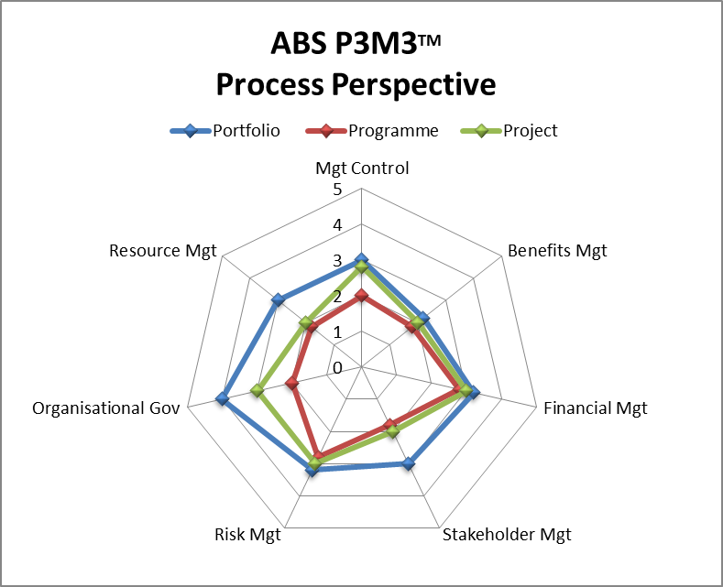

P3M3™ Generic Attributes Scores

Roles and Responsibilities
Portfolio Level 3
Programme Level 2
Project Level 2

Experience in Portfolio and/or Programme and /or Project Management
Portfolio Level 4
Programme Level 3
Project Level 3

Capability Development
Portfolio Level 3
Programme Level 3
Project Level 3

Planning and Estimating Process
Portfolio Level 3
Programme Level 2
Project Level 2

Information and Documentation
Portfolio Level 2
Programme Level 2
Project Level 2

Scrutiny and Review
Portfolio Level 2
Programme Level 2
Project Level 2
Across all three sub-models the management elements that apply generically to all perspectives were of level 2 or 3 maturities. In the case of Portfolio Management staff experience was found to be at level 4. These include understanding of roles and responsibilities, recognised experience in portfolio, programme or project management, capability development including training and raising individual competencies, planning and estimating, Information and documentation management and scrutiny and review.
At the Programme and Project level the management elements that apply generically to all perspectives were of a level 2 or 3 maturity.
Oakton recommends that ABS consider improvement strategies for the following management elements:
- Centrally managed role definitions and sets of competencies defined and used to secure appointments across portfolio, programme and project management
- Plans developed to a central and consistent standard that is output or outcome based with evidence of using consistent estimation techniques and the recognition of dependencies between change initiatives
- Development and implementation of standard repositories including the introduction of agency-wide information standards on confidentiality, availability and integrity for portfolio, programmes and projects
- Introduction of independent reviews of initiative outcomes assured during the delivery life cycle.
The adoption of these recommendations will enable ABS to improve its maturity to level 3 in the future.

Generic Attribute Scores
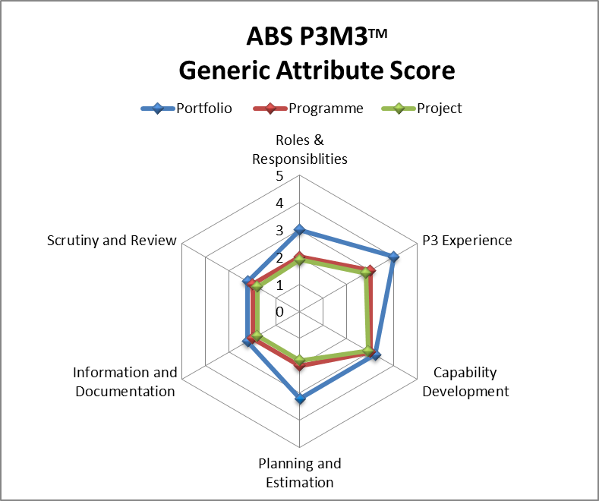

Agency Target Maturity Levels

Maturity Targets
Oakton recommends that ABS set target capability delivery maturity levels as follows:

Portfolio: Level 3 Defined Processes
Programme: Level 3 Defined Processes
Project: Level 3 Defined Processes

Gap Analysis
The following analysis identifies the process perspectives that are responsible for the maturity level score i.e. the low scoring process perspectives. The Capability Improvement plan needs to focus on improving these areas and addressing the ‘gap’.

Portfolio Level 2 => 3: Defined Processes
Management Control Level 3 => 3
Benefits Management Level 2 => 3
Financial Management Level 3 => 3
Stakeholder Management Level 3 => 3
Risk Management Level 3 => 3
Organisational Governance Level 4 => 4
Resource Management Level 3 => 3

Improvement in Benefits Management is required.

Programme: Level 2 => 3: Defined Processes
Management Control Level 2 => 3
Benefits Management Level 2 => 3
Financial Management Level 3 => 3
Stakeholder Management Level 2 => 3
Risk Management Level 3 => 3
Organisational Governance Level 2 => 3
Resource Management Level 2 => 3

Improvements in Management Control, Benefits Management, Stakeholder Management, Organisational Governance and Resource Management are required.

Project: Level 2 => 3: Defined Processes
Management Control Level 3 => 3
Benefits Management Level 2 => 3
Financial Management Level 3 => 3
Stakeholder Management Level 2 => 3
Risk Management Level 3 => 3
Organisational Governance Level 3 => 3
Resource Management Level 2 => 3

Improvements in Benefits Management, Stakeholder Management and Resource Management are required.

Attachments

Attachment A P3M3™ Model and Definitions

P3M3™ Model
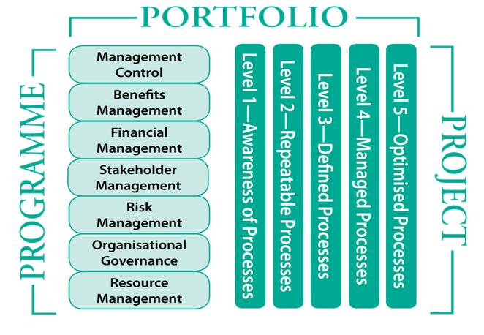
The following terms are used in the assessment of portfolios, programmes and projects.

Portfolio management
A Portfolio is the totality of an organisation’s investment (or segment thereof) in the changes required to achieve its strategic objectives.

Portfolio management is a coordinated collection of strategic processes and decisions that together enable the most effective balance of organisational change and Business as Usual (BAU).

Programme Management
A programme is a temporary, flexible organisation created to coordinate, direct and oversee the implementation of a set of related projects and activities in order to deliver outcomes and benefits related to the organisation’s strategic objectives.

Programme management is the coordinated organisation, direction and implementation of a dossier of projects and transformation activities to achieve the outcomes and realise the benefits that are strategic importance to the business.

Project Management
A project is a temporary organisation, usually existing for a much shorter duration (than a programme), which will deliver one or more outputs in accordance with a specific Business Case. A particular project may or may not be part of a programme.

Project management is the planning, delegating, monitoring and control of all aspects of the project, and the motivation of those involved, to achieve the project’s objectives with the expected performance targets of time, cost, quality, scope, benefits and risks.
The characteristics and elements of each process perspective are outlined below.

Management Control
Management control is characterised by clear evidence of leadership and direction, scope, stages, tranches and review processes during the course of initiatives. There are regular check points and clearly defined decision making processes. There are full and clear objectives and descriptions of what the initiative will deliver with a blueprint of the target operating model.

Benefits Management
Benefits management is the process that ensures the desired business change outcomes are clearly defined are measurable and are ultimately realised through a structured approach and with full organisational ownership. Benefits are assessed and approved by the organisational areas that will deliver them. Benefit dependencies and other requirements are clearly defined and understanding gained on how outputs of the initiatives will meet those requirements. There should be evidence of suitable classification of benefits and holistic view of the implications being considered. All benefits should be owned, have realisation plans and be actively managed to ensure they are achieved. There is a focus on operational transition with review and follow up on actions needed to ensure benefits are owned and realised.

Financial Management
Financial management ensures that the likely costs of the initiatives are captured and evaluated with a formal business case and that costs are categorised and managed over the investment lifecycle. There should be evidence of involvement of the Agency’s financial functions, with approvals imbedded in the broader organisational hierarchy. The business case should define the value of the initiative to the business and contain a financial appraisal of the possible options. The business case will be at the core of decision- making during the initiative’s lifecycle, and be linked to formal review stages and evaluation of the costs and benefits associated with alternative actions. Financial management will schedule the availability of funds to support the investment decisions.

Stakeholder Management
Stakeholders are the key to the success of any initiative. Stakeholders at different levels within and outside the organisation will need to be analysed and engaged effectively in order to achieve the objectives in terms of support and engagement. Stakeholder engagement includes communications planning, the effective identification and use of different communication channels, and the techniques to enable the objectives to be achieved.
Stakeholder engagement is an ongoing process across all initiatives and is inherently linked to the initiative’s lifecycle and governance controls.

Risk Management
Risk management provides a view on the way opportunities and threats presented by the initiative. Risk management maintains a balance of focus on threats and opportunities with appropriate management actions to minimise or eliminate the likelihood of any identified threat occurring, or minimise the impact if it does occur, and to maximise opportunities.

Organisational Governance
This looks at how delivery of initiatives is aligned to the direction of the organisation. It considers how start-up and closure controls are applied to initiatives and how alignment is maintained during an initiative’s lifecycle. This differs from management control which views how control of initiatives is maintained internally. This perspective looks at how external factors that impact on the initiative are controlled if possible or mitigated if not. The management of these external factors are used to maximise the final result. Effective sponsorship is critical to this.

Resource Management
Resource management covers all types of resources required for delivery. These include human resources, buildings, equipment, supplies, information, tools and supporting teams.
A key element in the management of resources is the process of acquiring resources and how supply chains are utilised to maximise effective use of resources. There will be evidence of capacity planning and prioritisation to enable effective resource management. This would also include performance management and exploitation of opportunities for greater utilisation. Resources capacity considerations will be extended to the capacity of the operational groups to resource the implications of change.

Maturity Level Definitions

Maturity Level 1 - Awareness of Process
- Processes are not usually documented, actual practice is determined by events or individual preferences, and performance is variable.
- Successful initiatives are often based on key individuals’ competencies rather than organisation wide capability and past successes can not be repeated consistently.
- Processes are undeveloped or incomplete. There is little or no guidance or supporting documentation and even terminology may not be standardised.

Maturity Level 2 - Repeatable Processes
- Basic management practices, e.g. tracking expenditure and scheduling resources, are in place and being improved. Key individuals are trained and demonstrate a successful track record and through them, the organisation is capable of repeating success.
- Initiatives are performed and managed according to their documented plans; project status and delivery is visible to management at defined points.
- There may still be inadequate measures of success; unclear responsibilities; Ambiguity /inconsistency in business objectives; unintegrated Risk Management; limited Change Management; and inadequacies in communications strategy.

Maturity Level 3 – Defined Processes
- Management and technical processes are documented, standardised and integrated to some extent with business processes. There is some process ownership and a group responsible for maintaining consistency and delivering process improvements.
- Senior management are engaged consistently, providing active and informed support.
- There is an established training programme to develop individual’s skills and knowledge.

Maturity Level 4 – Managed Processes
- The organisation has defined processes that are quantitatively managed, i.e. controlled using metrics. There are quantitative objectives for quality and process performance, and these are being used in managing processes.
- Top management are proactively seeking out innovative ways to achieve goals.
- Using metrics, management can effectively control processes and identify ways to adjust and adapt them to particular initiatives without loss of quality.

Maturity Level 5 – Optimised Processes
- There is focus on optimisation of quantitatively managed processes to account for changing business needs. The organisation exhibits continuous process improvement, and can show strong alignment of organisational objectives with business plans.
- Top managers are seen as exemplars, reinforcing the need and potential for capability and performance improvement.
- Information from process and product metrics enables the organisation to understand causes of variation and to optimise its performance.

Attachment B Terminology

Acronym | ABS or P3M3™ / OGC Term
P3M3 | Portfolio, Programme, Project Management Maturity Model
ACO | Accredited Consulting Organisation
RC | Registered Consultant
APMG | The organisation that maintains certifications for ACOs and RCs.
SEC | Senior Executive Committee
CSC | Capital Strategy Committee
IMTP | Information Management Transformation Programme
ELG | Executive Leadership Group
TSD | Technology Services Division



Melbourne
Level 8, 271 Collins Street
Melbourne VIC 3000
Australia
Sydney
Level 3, 65 Berry Street
North Sydney NSW 2060
Australia
Canberra
2/45 Wentworth Avenue
Kingston ACT 2604
Australia
Brisbane
Level 1, 46 Edward Street
Brisbane QLD 4000 Australia
Hyderabad
Plot No 5, Road No 2
Banjara Hills Hyderabad 500-034
Andhra Pradesh
India

© 2010 Oakton Services Pty Ltd
ABN 31 100 103 268

