Looking at where I live using Census 2006 data.

We know that student engagement can be increased when learning has relevance and when they are able to use technology.
In this activity students use data from the 2006 Census of Population and Housing to learn about their own area and how it compares to Australia as a whole. If student internet access is not available, teachers can select and make copies of the data for their class. Students can then start at task 2.

Task 1: Selecting and Getting to Know the Data for Your Area

 | Task
1. | Enter the address www.abs.gov.au into the address bar.
2. | Select ‘Census’ from the global menu that runs horizontally across the top of the homepage.
3. | Select Data under Census Data  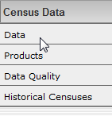  in the Quicklinks menu that runs  down the left hand side of the page.
4. | Go to Quick Stats and select 2006 Quick Stats.  Enter your postcode or name of your locality into the Search Box and select Search.
5. | Double click on the location you want then select  View Quick Stats >. You should see a summary of the Census data that was collected for your area in 2006. Note: data can be selected then copied and pasted into a spreadsheet.

Task 2: Selecting and Getting to Know the Data for Your Area
You will notice that the data about your area has been organised into categories. All Quick Stats categories contain data for that particular area as well as data for the whole of Australia.

1. When we comment on statistical information we usually start by focusing on the areas that are the same as well as those that are very different. Read the information about your area carefully.

a) Write three things about your area that are what you expected.

b) Write three things about your area that are not what you expected.

2. a) Look at the percentage results for your area compared to the results for Australia. Discuss with a friend the way(s) in which the percentages are similar. Write them below.

b) Choose one of these and use the axes below to draw a side by side bar graph to show the similarities.
Remember to give your graph a title and label your axes
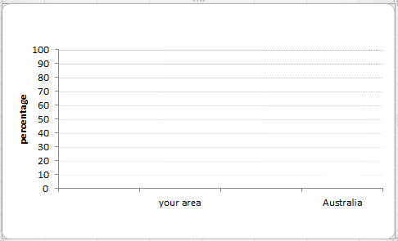

3. a) Discuss in what way(s) your area’s percentages are very different from the Australian population as a whole. Write them below.

b) Draw another side by side bar graph below to show one of the differences.

4. You know your region very well. What might be the reasons for these similarities and differences?

5. Imagine you are a journalist for your local newspaper just after these statistics were released. Write a newspaper report that explains the important statistics for your area.
You might want to include what effects they might have on future needs of your area.

